PROJECT REPORT

ON

ORACLE HEALTHCARE MANAGEMENT SYSTEM

Submitted to

NMAM INSTITUTE OF TECHNOLOGY, NITTE
(Off-Campus Centre, Nitte Deemed to be University, Nitte 574 110, Karnataka, India)

In the partial fulfilment of requirements for the award of degree

BACHELOR OF ENGINEERING
IN

INFORMATION SCIENCE AND ENGINEERING
By

BINDU.A NNM24IS058

Under the guidance of

Dr. JASON ELROY MARTIS
Associate Professor



Abstract

Running a hospital every day is very complicated than it seems. Staff have to manage many responsibilities at once such as keeping track of patient records, arranging appointments checking doctor availability and handling billing information. In many hospitals these tasks are still managed manually or different systems that are not properly connected. As a result, issues like misplaced records slow updates billing errors and lack of coordination between departments often rises. These problems can make the work environment mentally tired and may also affect the quality of care given to patients.

Tasks that once took lot of time and effort can be handled more quickly and in a more organized way by introducing better structured healthcare management system like everyday hospital activities can run much more nicely and finally this project shows that when there is proper planning, clear understanding of requirements and step by step development process and hospital management becomes much simple and useful

INTRODUCTION

This assignment helps us to understand how software engineering can be used in a real hospital setting by taking the Oracle Healthcare Management System as an example. This shows that when there is a correct planning and clear understanding of requirements the full of system design, managing patient records, appointments and billing becomes very simple and less confusing.

Hospitals handle important and sensitive information every single day so accuracy really matter and better designed system may reduce common mistakes and make tasks easy and smoother for all the staff.

The main intention of this assignment is to understand how to recognize what the users actually need from a healthcare system and how those needs can be studied before developing any software. It is focused on learning how to analyse system requirements properly and then use that to create a good organized healthcare management solution. Another purpose of this assignment is to that choosing the right software development will make the system more dependable easier to use and simple to maintain in the future. When system is built with proper planning and structure. It will reduce confusion and it helps everything run more easily.

This assignment also let us know how modern technologies can improve healthcare services and introducing basic ideas of deep learning to show how technology can handle large amounts of medical data finding like one patterns and support better decision making.
PROBLEM STATEMENT

Running hospital on a daily is not easy as many tasks need to be handled at the same time and when patient record the appointments and billing are managed manually or through separate and it can also be a confusion delays and small errors that can affect both the staff and the patients.

Task to be solved

The project is about creating a simple and practical healthcare management system that brings patient record appointments and billing together in one place. Doing this handling everything manually the system is designed to make work easier and reducing common mistakes so hospital staff can quickly access the information which they need without any confusion

Expected Outcomes

Projects encourage good coordination between different departments by allowing them to share data smoothly and efficiently. By the end the goal is to create a depends and can user friendly system that makes daily hospital operations more organized faster and less tension for all.

Constraints and Assumption

For this project we assume that hospital staff have basic computer knowledge and will enter correct information into the system. The system focused on handling the need to be tasks such as managing patient record and appointments and billing and it does not include advanced features like ai based or remote patient monitoring and as those are beyond the scope of this project.

Dataset Description

System Name

Oracle Healthcare Management System
This project dataset is designed to look good and feel like the good information real hospital handles every day through the oracle healthcare management system and it have details such as patient records, doctor schedules, appointment information, and billing data and then because of this real hospital data is private and highly sensitive and we do not use real patient information. Other than doing this we create sample data that closely reflects real hospital activities. This includes us to test system in safe and good way when still keeping it good one.

The data set includes nearly 1000 records and common hospital cases representing. then organizing the data into these categories we can manage and analyse it more effectively just like a real hospital.

Dataset has three part those are 70% is used for training the system and another one is 15% for validation and one more is 15%for testing.

Data processing

Before using the data set all the information carefully checked and cleaned arranging in correct way. Any missing data set values are incorrect and in different format are standardized to make sure everything follows the same way. This dataset make clear organized and easier to work with that.

In sometime values are also adjusted so the system can process them smoothly without confusion and taking these steps helps reducing error and improving the performance of the system. finally the healthcare system can handle patient records, appointments, and billing more efficiently accessing us to test it in a way that close fully reflects how it would function in a real hospital environment.

Tools and Technologies

For this project, Python was selected because it is simple to understand and easy to work and highly effective for handling data and building software systems. With the help of its powerful libraries, testing the system and visualizing data becomes much easier. It allows us to manage patient records, appointments and billing in a smooth and traditional way. Python also helps different parts of the healthcare management system connect and work together properly making the full development process faster more reliable and easier to manage.

To build and test the system effectively a few important Python libraries are used. It helps structure and process the system’s data efficiently so everything runs correctly. NumPy is helpful for managing numerical data and performing calculations quick which is better one when working with patient information, appointment schedules, and billing records.

To illustrate the data, we use Matplotlib and Seaborn, which enable the creation of well-structured and informative graphs and charts. These help to visualize the performance of the system and identify the patterns and trends in the data. Working with these tools helps improve the development process to help the focus be on improving the system's accuracy, efficiency, and reliability.

Hardware Used

This project is designed to run smoothly on a daily computer using a CPU which is more than enough for testing and handling daily hospital tasks. Since most hospital systems already use basic compute this makes the system practical and cost effect without requiring special hardware.

If the system needs to manage larger data or perform complex processing in the future a GPU will be added and it improve speed and also improves its overall performance. This ensures that the system works well on hospital computers and still allowing room for better performance whenever needed. Then this setup keeps the things simple affordable and efficient.

Methodology / Process Models

Waterfall Model

Waterfall Model is one of the simplest and oldest approach to develop software. In this methodology work is performed in a step by step sequence. First the needs are accurately understood and documented. Then a system is planned and then it is coded. Then the code is tested and deployed and maintained. Each is finished before one moves along to the next as with going down step a waterfall.

For a project, this method is helpful because it encourages careful planning from the beginning. All requirements are documented clearly before development starts which reduces confusion and helps prevent mistakes. This is especially important in hospitals, where accuracy and clarity really matter.

For a public health management platform this is useful as it will prompt thoughtful planning early on. All the requirements are clearly documented prior to the start of development which minimizes confusion and mistakes from happening. This is particularly true in hospitals where accuracy and precision of language actually matters. The Waterfall Model The biggest con to the Waterfall Model was that it was not adaptable. And, if there is a change in requirement in the middle of development it can be quite hard to make changes.
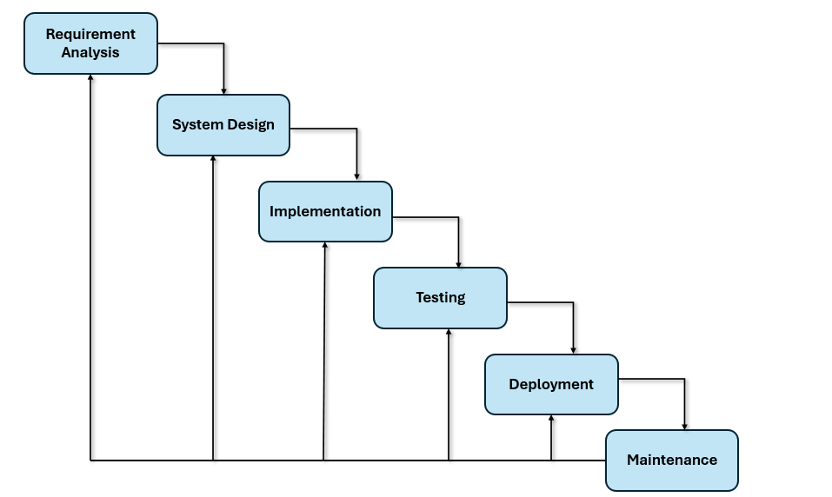

Incremental Development Model

The basic idea behind the incremental development model is to build the system gradually rather than attempting to finish it all at once. The group breaks the healthcare system up into smaller components and works on each one gradually rather than creating the entire system all at once. One part was completed, delivered, and made usable before going on to the next

This method works very well for a big system like Oracle Healthcare. The team could, for instance, start by creating the module for patient registration and basic record management. They can then add the prescription system, lab integration, and eventually billing and reporting features once that is stable and operating correctly. In this manner, new features can be added gradually while hospitals can begin using the system early.

One of the advantages of this model is flexibility. The healthcare sector is always prone to changes in rules and regulations. Changes in government regulations or demands from doctors for improvement can occur. By applying the incremental model, changes can be easily incorporated into the next phase without disrupting the whole process. It also reduces risks because problems are identified in smaller pieces that are easy to solve
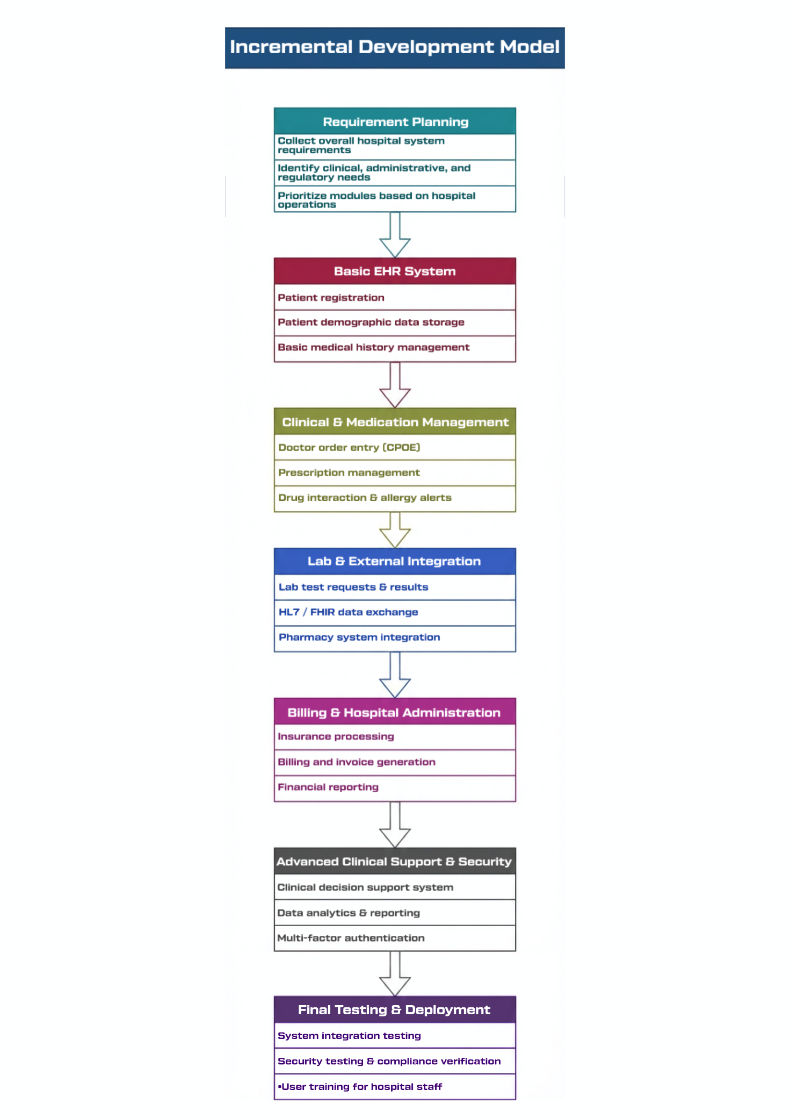
Spiral Model

For a healthcare system like oracle health this is very useful because hospitals deals with very sensitive or emotional data and patient safety. if there is even a small mistake in medication or patient records it can create very serious problems. So in this model before building prescription module the team asks questions. For example What if the dosage alert fails? What if data gets hacked? What if the system crashes in an emergency? After keeping all this in mind they build small version and they test it with doctors then fix issues and at last improve it in the next round.

For a healthcare system like oracle health this is very useful because hospitals deals with very sensitive or emotional data and patient safety. if there is even a small mistake in medication or patient records it can create very serious problems. So in this model before building prescription module the team asks questions. For example What if the dosage alert fails? What if data gets hacked? What if the system crashes in an emergency? After keeping all this in mind they build small version and they test it with doctors then fix issues and at last improve it in the next round

This will be repeating till the whole system becomes strong and safe. One of the biggest benefit in this model is that it reduces risk and improves the system step by step. It also allow changes if hospital rules or government regulations are updated.

Risk Analysis:
• Identify patient safety risks
• Analyse data security threats
• Evaluate technical and cost risks
• Propose alternative solutions

Testing & Evaluation:
• Test developed healthcare module
• Conduct user testing with doctors
• Collect feedback
• Improve and validate system

Engineering (Design & Development):
• Design system architecture
• Develop EHR modules (Registration, Prescription, Lab, Billing)
• Implement security mechanisms
• Integrate database and cloud systems

Planning:
• Identify hospital objectives
• Gather clinical and administrative requirements
• Understand regulatory compliance (HIPAA, ISO standards)
• Plan project timeline and resources.

Requirements Engineering

Functional Requirements

The Oracle Healthcare System should make everything easy for hospitals to manage patient information. it should also allow the staff to register the patient and their medical details in one file, such as lab reports, medical bills, etc. It should also allow the doctors to add the treatment plan directly to the system and it should directly warm them if there is any allergy issues. The system should also be connected with lab, pharmacy, and bill department so that everything would go smoothly. At same time, patient information should be secured and should only allow the access only to the given users and all action in system should be tracked to check the safety,

Non-Functional Requirements

The Oracle Healthcare system really do not have down time. every single minute doctors and nurses look in it, so it has to run daily. Patient records should come up fast so nobody needs to wait around for a computer. Since it holds important medical information, it should have strong login or password. The system should handle a crowd without dragging even during busy time. It also have the strict healthcare rules like HIPPA which means to keep the patient information protected.

Requirements Validation Strategy

After we collect all the requirements, we should not just move forward and start building the system. We need to sit back and check if everything actually makes sense. This checking process is called requirements validation. It means making sure that what we wrote is really what the hospital wants. For the Oracle Healthcare system, this can be done by discussing the requirements with doctors, nurses and hospital staff. We can ask them is this what you expect? is anything missing? Sometimes when they see simple demo screens or they realize new things. That feedback is very important By doing this early we avoid confusion later. It saves time and money and reduce big mistakes. In healthcare, where patient safety is involved.

Implementation Details

For this project, I kept application simple and systematic so that I would not get confused later when testing or making some changes. Instead of putting everything in one big file, I separated the code into many different modules. one file handled data loading and preprocessing another defined the architecture of model and another one managed the training and evaluation process. All this parts are connected by the main file and also it controlled the full workflow

During the training I used mini batch learning method instead of giving the entire dataset at once. This data was divided into smaller batches so that the model could learn one by one in a perfect way. I trained the model for certain time by allowing it to go through the data several times and improve gradually. After each and every batch the loss was calculated to measure how much error the model made and the optimizer also updated the weights to reduce that error. I also checked validation performance after every period to make sure the model was learning properly and it was not just memorizing the training data.

Experiments Performed

In this project, I have performed several small experiments to improve performance of Oracle Healthcare Management System model. At first I adjusted important parameters like learning rate, batch size and also number of neurons. When the learning rate was very high the model was not stable enough and accuracy was also poor. When it become too low the training became very slow. Then I carefully turned these values one by one and observed some changes. I also tested different batch sizes to get a good balance between training speed and also in stable learning

Results and Analysis

After completing this project, it became very clear that choosing the right SDLC model really matters for a system like Oracle Health, because this is not some small app it handles real patient data and hospital operations. When I comparing waterfall, incremental and spiral I understood that waterfall is okay when everything was fixed from the beginning but in healthcare rules and requirements keep changing. So it becomes danger . In a healthcare system, where even a small mistake can affect patient risk handling is very important. Incremental was better because features can be added step by step, which gives some flexibility. But honestly, Spiral looked the strongest because it focuses mainly on risk analysis at all stage. The comparison tables and simple graphs in the report clearly show how Spiral manages change and risk better than the other two. Based on all this analysis, Spiral Model feels like the safest and most practical choice for a large healthcare management system.

Discussion

Interpretation of Results

After comparing the model it is clear that not all of them correct match to a healthcare system in same. Incremental allows gradual development. Waterfall is structured but not flexible and spiral is the most suitable because it focusing on managing risks which is very important in a hospital system.

Comparison Between Different Models

Waterfall is simple but rigid. Incremental is more flexible and develops the system step by step. Spiral is better for high risk systems because it checks risks in every cycle.
like oracle healthcare

Challenges Faced During Implementation

Understanding different stakeholder needs was challenged. Balancing security, usability and regulatory requirements and careful communication was needed to bring everyone requirements together.

Limitations and Future Work

Limitations

A limitation of this study is that it is largely based on knowledge and research, and not actual clinical testing in a hospital. It was impractical to implement and test the models in a real setting, as Oracle Healthcare is an large and intricate system. As such, some practical problems, such as user difficulties technical malfunctions or sudden change may not be totally grounded in the analysis.

Framework

In upcoming years this work can be improved by creating a more practical framework that is specially designed for healthcare systems. Strong risk management, regular feedback from doctors and strict security measures can be combined in this framework. Modern approaches like Agile practices and advanced technologies such as AI to make the system smarter and more efficient can be included.

Conclusion

In this project we learnt different software development models and also understood how we can use them in complex system like Oracle healthcare. By comparing Waterfall, Incremental and Spiral models we understood that all models have its own strengths but some are suitable for healthcare because of safety and risk factors. It also made us to understand how important it is to clearly define and validate requirements before starting development. This project made us to get realize careful planning, proper requirement analysis and also risk management are very important when building systems that handle sensitive patient data and critical hospital operations.

References

1] I. Sommerville, Software Engineering, 9th ed., Pearson, 2011.
[2] B. W .Boehm, “A Spiral Model of Software Development and Enhancement” Computer, vol. 21, no. 5, pp. 61–72, 1988.
[3] IEEE, IEEE Recommended Practice for Software Requirements Specifications, IEEE Std 830-1998, 1998.
[4] ISO, Medical Device Software-Software Life Cycle Processes, ISO 62304, 2006.
[5] U.S. Department of Health & Human Services, “Health Insurance Portability and Accountability Act ” 2023. Available: https://www.hhs.gov/hipaa/
[6] Oracle Corporation, Oracle Health Electronic Health Record Solutions, 2024.

Git hub Link:

DECLARATION

I hereby declare that this assignment is my original work and has not been copied or plagiarized from any source. All references used have been properly cited. Any ambiguities will lead forfeiting my marks.

Student Signature:



Date: 15th February 2026

